MDHHS – MCIR Release Notes

Version 2024 – MCIR OLTP 2024 24.6.12 – RFC 237997 Release Date: 06/12/2024

Forecasting & Assessment – 4 Items

1. HPV 2nd dose accelerated date needs to display 1 month from dose 1, 2 months from dose 1 for recommended and overdue for 15 years of age and older. (Ref# 2972)

Status Screen:

Landscape Report: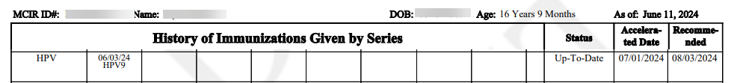

* Please refer to the link below:
* [HPV Vaccine Schedule and Dosing | CDC](https://www.cdc.gov/hpv/hcp/schedules-recommendations.html)

1. Hep B Not Displaying on Status Screen School/Childcare Sites (Ref# 2971)

Information Screen:

Status Screen:

1. HepB doses not evaluated, HPV9/HIB does not appear in status for eligible individuals (Ref# 2954)

HPV: Status Screen

HPV: Landscape Report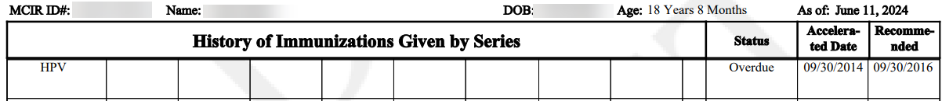

HIB: Status Screen

1. COVID-19 - Forecast for 65 years and older 1 additional dose of any updated (23–24 Formula) COVID-19 vaccine at least 4 months after previous dose of updated (23–24 Formula) (Ref# 2973)

Status Screen

Please refer to the link below:

[Clinical Guidance for COVID-19 Vaccination | CDC](https://www.cdc.gov/vaccines/covid-19/clinical-considerations/interim-considerations-us.html#table-01)

If you have questions or need assistance, please contact your Field Representative or

**MCIR SOM Help Desk at** [MDHHS-MCIRHelp@michigan.gov](mailto:MDHHS-MCIRHelp@michigan.gov)**.**